Fast Food Marketing Campaign A\B Test

# **Introduction**

This is an analysis of Fast Food Marketing Campaign A\B Test. A fast-food chain plans to add a new item to its menu. However, they are still undecided between three possible marketing campaigns for promoting the new product. In order to determine which promotion has the greatest effect on sales, the new item is introduced at locations in several randomly selected markets. A different promotion is used at each location, and the weekly sales of the new item are recorded for the first four weeks.

# **Goal of the Test**

The main goal of this A/B test is to decide which marketing campaign should be used for promoting a new product.

For the analysis of A/B test results I conducted 3 tests, comparing the three campaigns against one another and i used a confidence level of 99% to reduce the chance of getting a type I error (false positive)

# **Target Metric**

The dataset provides one metric:

* *SalesInThousands*: sales amount for a specific *LocationID*, *Promotion*, and *week*

Since the goal of the AB test was to increase sales, I will use *SalesInThousands* since it aligns with the goal of the test.

Therefore, the target metric of the A/B test is *SalesInThousands*.

# **SQL Query**

**SELECT**

**location_id,**

**promotion,**

**AVG(sales_in_thousands) AS avg_sales,**

**COUNT(week) AS weeks_count**

**FROM**

**`tc-da-1.turing_data_analytics.wa_marketing_campaign`**

**GROUP BY**

**location_id,**

**promotion**

**ORDER BY**

**promotion, location_id;**

# **ANALYSIS**

The table contains the numbers necessary to analyze the A/B test and reach a decision.

| **promotion** | **avg_sales** | **weeks_count** | **location_id** |
| --- | --- | --- | --- |
| 1 | 40.68 | 4 | 3 |
| 1 | 43.2425 | 4 | 7 |
| 1 | 39.515 | 4 | 9 |
| 1 | 37.785 | 4 | 12 |
| 1 | 42.3725 | 4 | 13 |
| 1 | 65.6 | 4 | 101 |
| 1 | 87.415 | 4 | 202 |
| 1 | 95.09 | 4 | 209 |
| 1 | 89.2625 | 4 | 210 |
| 1 | 87.375 | 4 | 214 |
| 1 | 91.125 | 4 | 218 |
| 1 | 90.3425 | 4 | 220 |
| 1 | 86.92 | 4 | 222 |
| 1 | 58.8875 | 4 | 303 |
| 1 | 58.6875 | 4 | 304 |
| 1 | 60.7425 | 4 | 306 |
| 1 | 56.895 | 4 | 309 |
| 1 | 53.76 | 4 | 410 |
| 1 | 57.2725 | 4 | 412 |
| 1 | 43.3225 | 4 | 504 |
| 1 | 40.315 | 4 | 509 |
| 1 | 37.8175 | 4 | 512 |
| 1 | 42.19 | 4 | 513 |
| 1 | 39.68 | 4 | 514 |
| 1 | 52.0075 | 4 | 608 |
| 1 | 47.9925 | 4 | 609 |
| 1 | 51.0725 | 4 | 610 |
| 1 | 49.4125 | 4 | 613 |
| 1 | 49.4 | 4 | 702 |
| 1 | 50.6425 | 4 | 703 |
| 1 | 52.3925 | 4 | 704 |
| 1 | 49.75 | 4 | 707 |
| 1 | 53.515 | 4 | 711 |
| 1 | 56.635 | 4 | 801 |
| 1 | 57.295 | 4 | 804 |
| 1 | 56.075 | 4 | 810 |
| 1 | 61.55 | 4 | 902 |
| 1 | 63.0575 | 4 | 909 |
| 1 | 64.18 | 4 | 910 |
| 1 | 60.49 | 4 | 913 |
| 1 | 59.42 | 4 | 915 |
| 1 | 55.975 | 4 | 918 |
| 1 | 61.1 | 4 | 919 |
| 2 | 29.545 | 4 | 2 |
| 2 | 33.7075 | 4 | 4 |
| 2 | 29.0025 | 4 | 5 |
| 2 | 27.84 | 4 | 8 |
| 2 | 30.665 | 4 | 10 |
| 2 | 83.1575 | 4 | 204 |
| 2 | 82.9475 | 4 | 211 |
| 2 | 76.82 | 4 | 213 |
| 2 | 80.405 | 4 | 215 |
| 2 | 77.0225 | 4 | 219 |
| 2 | 77.2 | 4 | 221 |
| 2 | 52.26 | 4 | 301 |
| 2 | 50.5625 | 4 | 305 |
| 2 | 48.135 | 4 | 307 |
| 2 | 52.285 | 4 | 308 |
| 2 | 45.425 | 4 | 402 |
| 2 | 46.025 | 4 | 403 |
| 2 | 43.3875 | 4 | 404 |
| 2 | 46.655 | 4 | 405 |
| 2 | 45.9725 | 4 | 406 |
| 2 | 44.33 | 4 | 408 |
| 2 | 46.81 | 4 | 409 |
| 2 | 48.7375 | 4 | 413 |
| 2 | 32.8175 | 4 | 502 |
| 2 | 35.785 | 4 | 503 |
| 2 | 38.34 | 4 | 505 |
| 2 | 31.005 | 4 | 506 |
| 2 | 28.1425 | 4 | 507 |
| 2 | 29.4875 | 4 | 510 |
| 2 | 36.5275 | 4 | 603 |
| 2 | 40.93 | 4 | 607 |
| 2 | 36.2 | 4 | 614 |
| 2 | 43.79 | 4 | 615 |
| 2 | 42.105 | 4 | 708 |
| 2 | 42.89 | 4 | 709 |
| 2 | 48.79 | 4 | 802 |
| 2 | 51.175 | 4 | 807 |
| 2 | 48.495 | 4 | 901 |
| 2 | 51.005 | 4 | 904 |
| 2 | 49.0475 | 4 | 906 |
| 2 | 48.16 | 4 | 907 |
| 2 | 47.0625 | 4 | 908 |
| 2 | 52.7325 | 4 | 911 |
| 2 | 49.325 | 4 | 912 |
| 2 | 46.6 | 4 | 914 |
| 2 | 47.76 | 4 | 916 |
| 2 | 47.4125 | 4 | 920 |
| 3 | 34.42 | 4 | 1 |
| 3 | 31.185 | 4 | 6 |
| 3 | 36.3625 | 4 | 11 |
| 3 | 60.2875 | 4 | 102 |
| 3 | 64.34 | 4 | 103 |
| 3 | 63.0175 | 4 | 104 |
| 3 | 58.285 | 4 | 105 |
| 3 | 59.0375 | 4 | 106 |
| 3 | 81.3075 | 4 | 201 |
| 3 | 83.34 | 4 | 203 |
| 3 | 87.0675 | 4 | 205 |
| 3 | 84.1425 | 4 | 206 |
| 3 | 86.1625 | 4 | 207 |
| 3 | 88.5775 | 4 | 208 |
| 3 | 82.77 | 4 | 212 |
| 3 | 86.0225 | 4 | 216 |
| 3 | 84.905 | 4 | 217 |
| 3 | 52.1175 | 4 | 302 |
| 3 | 49.04 | 4 | 401 |
| 3 | 47.165 | 4 | 407 |
| 3 | 52.995 | 4 | 411 |
| 3 | 55.28 | 4 | 414 |
| 3 | 49.715 | 4 | 415 |
| 3 | 33.9125 | 4 | 501 |
| 3 | 32.33 | 4 | 508 |
| 3 | 43.1925 | 4 | 511 |
| 3 | 37.625 | 4 | 515 |
| 3 | 43.815 | 4 | 601 |
| 3 | 43.2075 | 4 | 602 |
| 3 | 44.025 | 4 | 604 |
| 3 | 42.785 | 4 | 605 |
| 3 | 41.5625 | 4 | 606 |
| 3 | 46.71 | 4 | 611 |
| 3 | 47.0925 | 4 | 612 |
| 3 | 49.7225 | 4 | 701 |
| 3 | 49.125 | 4 | 705 |
| 3 | 49.9375 | 4 | 706 |
| 3 | 49.74 | 4 | 710 |
| 3 | 48.215 | 4 | 712 |
| 3 | 48.69 | 4 | 803 |
| 3 | 52.535 | 4 | 805 |
| 3 | 49.8525 | 4 | 806 |
| 3 | 60.2025 | 4 | 808 |
| 3 | 48.1575 | 4 | 809 |
| 3 | 51.86 | 4 | 903 |
| 3 | 57.325 | 4 | 905 |
| 3 | 52.9675 | 4 | 917 |

**Table 1. Summary of the results of the A/B test.**

| **promotion** | **mean** | **Std.Dev** | **Count** |
| --- | --- | --- | --- |
| 1 | 58.099 | 16.028 | 43 |
| 2 | 47.329 | 14.497 | 47 |
| 3 | 55.364 | 16.384 | 47 |

**Table 2. Summary of each promotion outcome.**

| **comparison** | **p-value** | **Cohen’s d** | **Standard ERROR** | **sigificance** |
| --- | --- | --- | --- | --- |
| 1 AND 2 | 0.00128 | 10.77 | 3.232 | significant at 99% |
| 1 AND 3 | 0.43 | 2.735 | 3.418 | Not significant at 99% |
| 2 AND 3 | 0.0136 | −8.035 | 3.191 | marginally significant at 99% |

**Table 3. Summary of 2 Sample T-Test comparing the promotions**

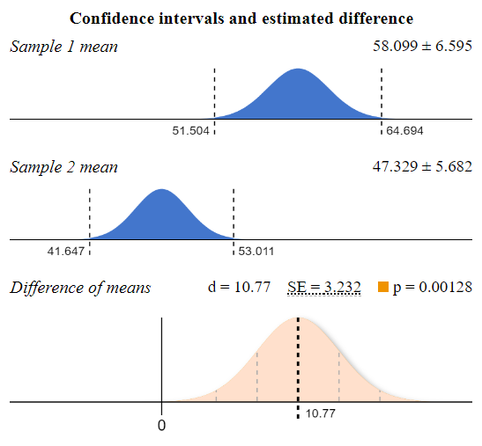

**Figure 1. 2 Sample T-Test comparing the promotion 1 and 2**

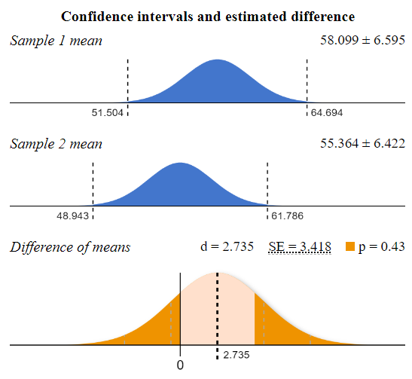

**Figure 2. 2 Sample T-Test comparing the promotion 1 and 3**

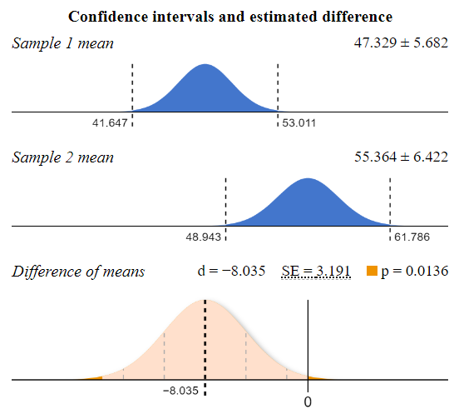

**Figure 3. 2 Sample T-Test comparing the promotion 2 and 3**

# **Evaluation**

**Cohen’s d values:**

* A d value of 10.77 for the first comparison indicates an extremely large effect size, suggesting a substantial difference between the two groups.
* A d value of 2.735 in the second comparison indicates a smaller effect size, though still considered a large effect.
* A d value of −8.035 in the third comparison suggests a very strong negative difference (in magnitude) between the two groups, meaning one promotion performed significantly worse than the other.

**p-values:**

* The first and third comparisons have p-values less than 0.01, indicating statistically significant differences between those groups.
* The second comparison, with a p-value of 0.43, shows no statistically significant difference.

This suggests that the first and third comparisons are important for determining the differences between the marketing campaigns. The second comparison shows that the two groups are not significantly different from one another.

# **Decision**

Choose **Promotion 1** as the most effective marketing strategy for the new item, as it has the highest average sales and statistically significant positive effects.

Avoid Promotion 2, which has the lowest average sales and does not show strong performance. Promotion 3 could be a secondary option but is also less effective than Promotion 1.

